DOCUMENT 05 — AIRA: AGI Intelligence & Runtime Architecture
Visionary Internal · v1.0 · Internal only — never public.

AIRA is the runtime that turns the VATS 7-layer architecture (Doc 03) into
deployable services. VATS says what the intelligence does; AIRA says how it
runs in production — services, context, memory, model routing, tool-calling,
safety, observability — for all four apps and all five stakeholders.

1. Purpose & Scope
Owns: the 19 microservices; the request lifecycle; context orchestration (P0–P3);
memory (short-term/episodic/semantic/procedural); multi-model routing; tool-calling;
safety; observability & evals.
Does NOT own: curriculum data (Doc 02), pedagogy theory (Doc 03), go-to-market (Doc 04).
Non-goals: autonomous open-ended agents; unguarded free-form generation; any live-AGI
claim in UI copy (Doc 01 honesty rule).

2. The 19 Microservices

# | Service | Layer | Responsibility
1 | api-gateway | — | Routing, authN, rate-limit, request contract
2 | auth-service | — | Phone OTP, profiles, sessions, role claims
3 | perception-service | L1 | ASR, language-detect, NLU → structured intent
4 | scm-service | L2 | BKT mastery state, prerequisite trace, ZPD window
5 | content-service | L2 | 7-level syllabus retrieval (Doc 02), KG nodes
6 | ate-service | L3 | Pedagogy selection, explanation strategy, comprehension-loop policy
7 | orchestrator-service | — | Request lifecycle, context assembly (P0–P3), tool dispatch
8 | inference-service | L4 | Model routing, streaming, token budgeting
9 | guard-service | L4 | NLI claim-check vs curriculum corpus, age/appropriateness filter
10 | viz-service | L5 | Emits [SCENE:…] tokens, 3D/2D fallback decision
11 | memory-service | L6 | Episodic + semantic store, "Things I remember" generator
12 | flywheel-service | L7 | Event ingest, quality filter, training-set builder
13 | practice-service | L3/L4 | Adaptive quiz (IRT), spaced-repetition scheduler
14 | build-service | — | Projects, artifacts, portfolio, peer-teach
15 | report-service | — | Parent weekly report, teacher class digest
16 | notification-service | — | Lifecycle nudges, revision reminders (consent-gated)
17 | billing-service | — | Plans, entitlements, family/org seats
18 | admin-service | — | Org cohorts, curriculum approval, RBAC
19 | eval-service | — | Offline evals, drift detection, A/B verdicts

3. High-Level Service Map
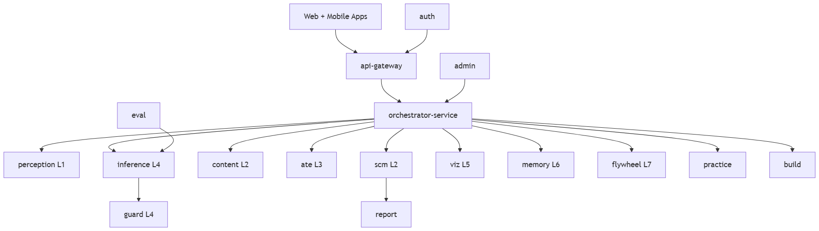

4. Request Lifecycle (one teaching turn)
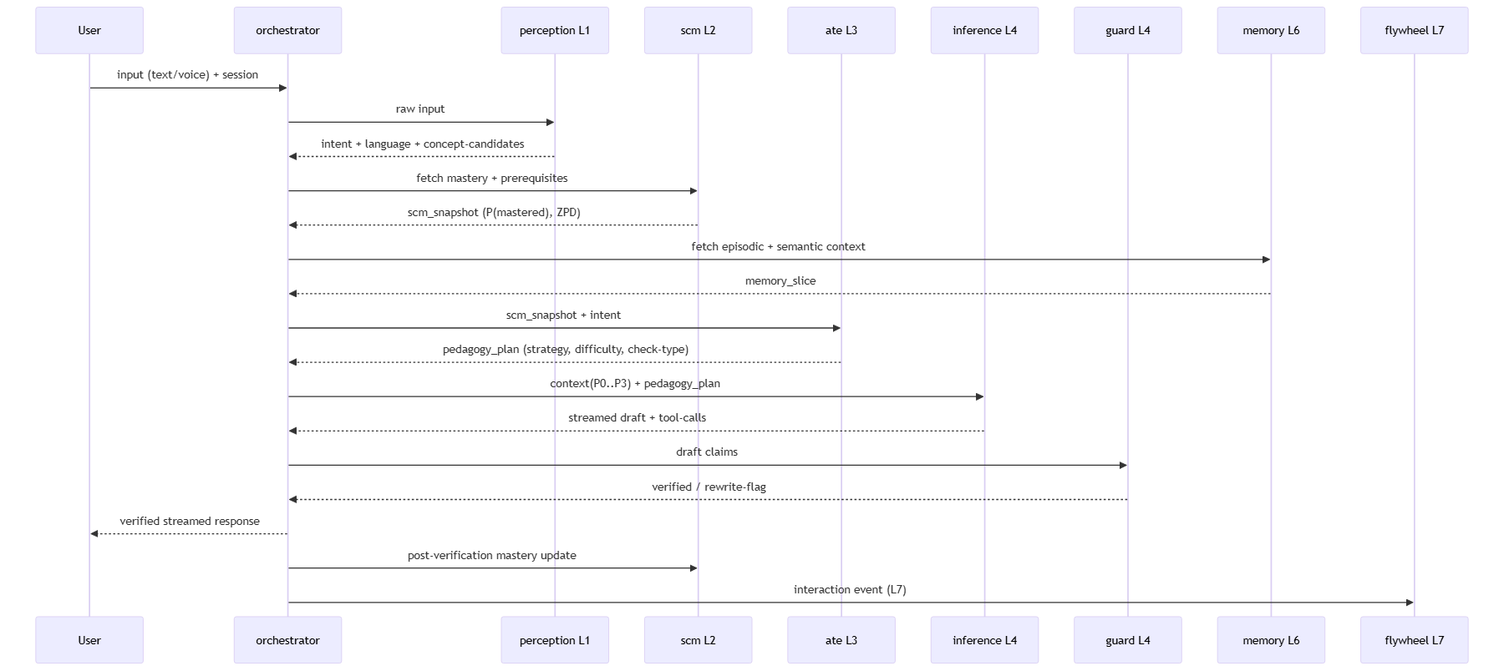
Latency budget (p95, 4G, ₹8k Android): perception ≤40ms · SCM ≤30ms · memory ≤30ms ·
ATE ≤20ms · TTFT ≤200ms · guard inline ≤60ms · viz first-frame ≤1.5s.

5. Context Orchestration (P0–P3)

Tier | Content | Always?
P0 | System constitution + role adapter + safety rules | Yes
P1 | Student state: SCM snapshot, learning-style, language, board/exam | Yes
P2 | Session: current chapter/concept, last N turns, active pedagogy | Yes
P3 | Retrieval: RAG facts, KG neighbors, memory observations | Budget-permitting

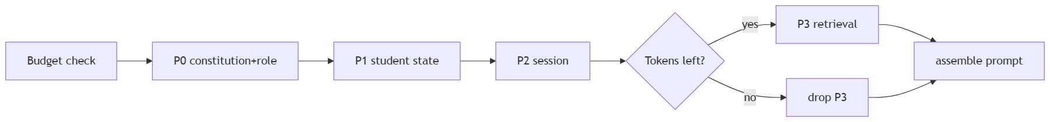
Rule: P3 is grounding only; it may not override P1 student state (ZPD difficulty wins).

6. Memory Subsystem

Store | Tech | Contents | TTL
Short-term | Redis | active session, draft, canvas state | session
Episodic | Qdrant | per-interaction embeddings | rolling
Semantic | Qdrant | concept-level facts the student knows | long
Procedural/SCM | Postgres | BKT mastery, prerequisites, pedagogy efficacy | permanent

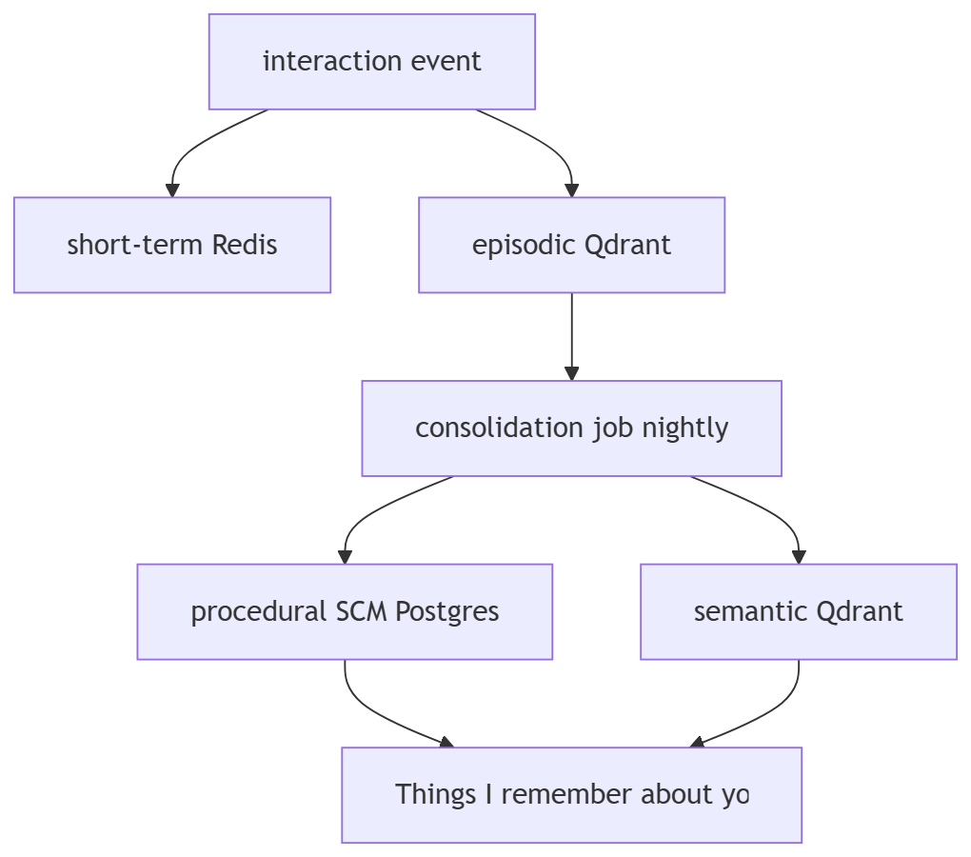
"Things I remember" emits 3–5 pattern-based observations weekly; never shows a bare 0
to a new user.

7. Multi-Model Routing
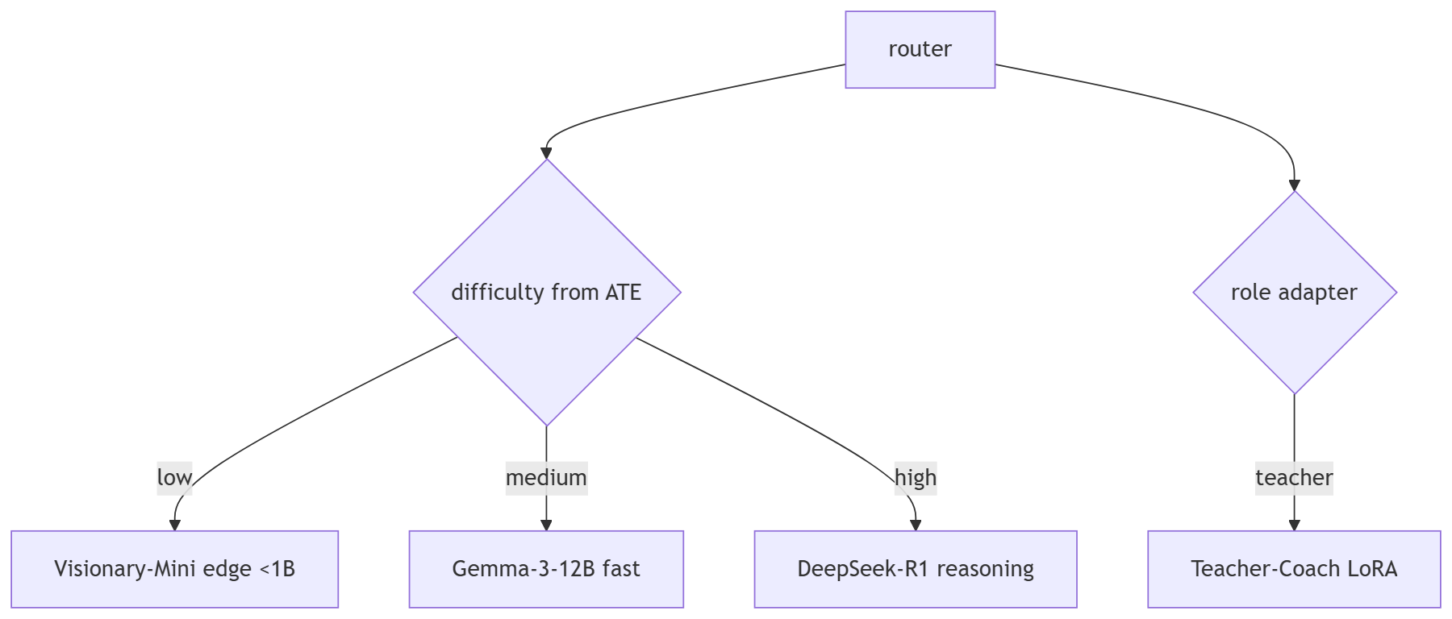

Phase | Models | Notes
1 (now) | DeepSeek-R1 + Gemma-3 via API | routing + caching
2 | + LLaMA-3.1-8B QLoRA fine-tune | India-edtech SFT/DPO
3 | + Visionary-Mini distilled | offline/edge, low-cost
DDR-05: routing thresholds re-tuned weekly from real comprehension-check outcomes.

8. Tool-Calling

Tool | Purpose
trigger_3d_scene(concept, params) | hand to viz-service
query_knowledge_graph(concept, depth) | prerequisite/neighbor facts
calculate_math(expr) | exact arithmetic (never LLM math)
fetch_student_mastery(concept) | live SCM value
schedule_revision(concept, when) | spaced-repetition
DDR-01: deterministic state-machines, not autonomous agents; tool-calls are the only
branching and each branch is bounded.

9. Safety Pipeline
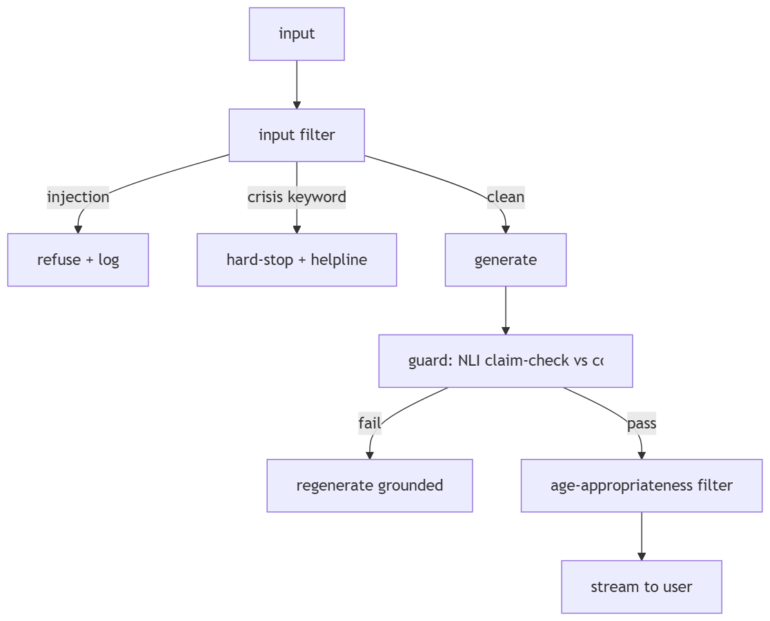
Crisis detection is a hard-stop on the L1 input path. Constitutional constraints live in
P0 and are re-asserted each turn. PII scrubbed before any event reaches the flywheel.

10. Observability & Evals
Every turn emits an L7 event: user_id, role, session, app, concept_id, input_type,
language, board/class/exam, pedagogy_used, model_routed, verification_result, latency,
prompt_version. eval-service gates deploys on no-regression (IndiaEdTech-Bench). Drift
alert when comprehension pass-rate drops >5% WoW for any concept.

11. Design Decision Records

ID | Decision | Why
DDR-01 | Deterministic state-machine orchestrator | Predictable, testable, safe for children
DDR-02 | Single orchestrator owns context assembly | One place to enforce budget + privacy
DDR-03 | P0–P3 priority with drop-order | Student-state always present
DDR-04 | Guard inline (parallel with stream tail) | TTFT ≤200ms + never ship unverified fact
DDR-05 | Router thresholds re-tuned from outcomes | Routing improves with flywheel
DDR-06 | Math via calculate_math, never LLM arithmetic | Zero tolerance for wrong numeric facts

12. Sprint Mapping (first 90 days)
Sprint 1: gateway, auth, perception, orchestrator skeleton, flywheel ingest (L7 from user #1).
Sprint 2: scm + content retrieval, ate pedagogy, inference routing (Phase-1), guard NLI.
Sprint 3: memory stores + "Things I remember", viz tokens, practice IRT, eval gate.

